Features
- 400Gb/s to 2x200Gb/s data rate
- 8x 50Gb/s PAM4 modulation
- Single 3.3V power supply
- Max 4.5W power dissipation each QSFP56 end
- Max 8W power dissipation OSFP end
- Compliant to CMIS V5.2
- Operating case temp Commercial: 0°C to +70 °C
- Hot pluggable
- RoHS compliant
Applications
- 400Gb/s systems
- Other optical links
Order Information
Table 1-Order Information
Part No. | Bit Rate  (Gbps) | Laser (nm) | Distance | Fiber Type | DDMI | Connector | Temp^{note1}
400G-OAOC-A2-Xm | 8x50 | 850 | 1~30m | MMF | YES | N/A | 0℃~+70℃
X: 1M~30M
Note: 1 Case Temperature
Absolute Maximum Ratings
Table2- Absolute Maximum Ratings
Parameter | Symbol | Min. | Typical | Max. | Unit | Notes
Supply Voltage | Vcc₃ | -0.5 | - | +3.6 | V
Storage Temperature | T_{s} | -10 | - | +75 | °C
Operating Humidity | RH | +5 | - | +85 | % | 1
Note: 1 No condensation

Recommended Operating Conditions
Table 3- Recommended operating Conditions
Parameter | Symbol | Min. | Typical | Max. |  | Unit | Notes
Operating Case Temperature | T_{C} | 0 | - | +70 | °C
Power Supply Voltage | Vcc | 3.14 | 3.3 | 3.47 |  | V
Power dissipation  (400G retiming on all lanes) | Pd_{400G} | - | - | 8 |  | W | 1
Power dissipation  (200G retiming on all lanes) | Pd_{200G} | - | - | 4.5 |  | W | 1
Note: 1 Per terminal
Electrical Characteristics
Table 4- Electrical Characteristics
Parameter | Symbol | Unit | Min | Typ | Max | Notes
Transmitter
Signaling rate (each lane) | SR | GBd | 26.5625 ± 100 ppm
Differential data input voltage per lane | Vin,pp,diff | mV | - | - | 900
Differential termination mismatchal | - | % | - | - | 10
Single-ended voltage tolerance range | - | V | -0.4 | - | 3.3
DC common mode voltage | - | mV | -350 | - | 2850
Receiver
Signaling rate (each lane) | SR | GBd | 26.5625 ± 100 ppm
Differential output voltage | - | mV | - | - | 900
Differential termination mismatch | - | % | - | - | 10
Transition time (min, 20% to 80%) | - | ps | 9.5 | - | -
DC common mode voltage | - | mV | -350 | - | 2850
Error Bit Rate | BER | - | - | - | 2.4E-4 | Note1
Note: 1 PRBS31Q@26.5625Gbd PAM4

Recommended Interface Circuit
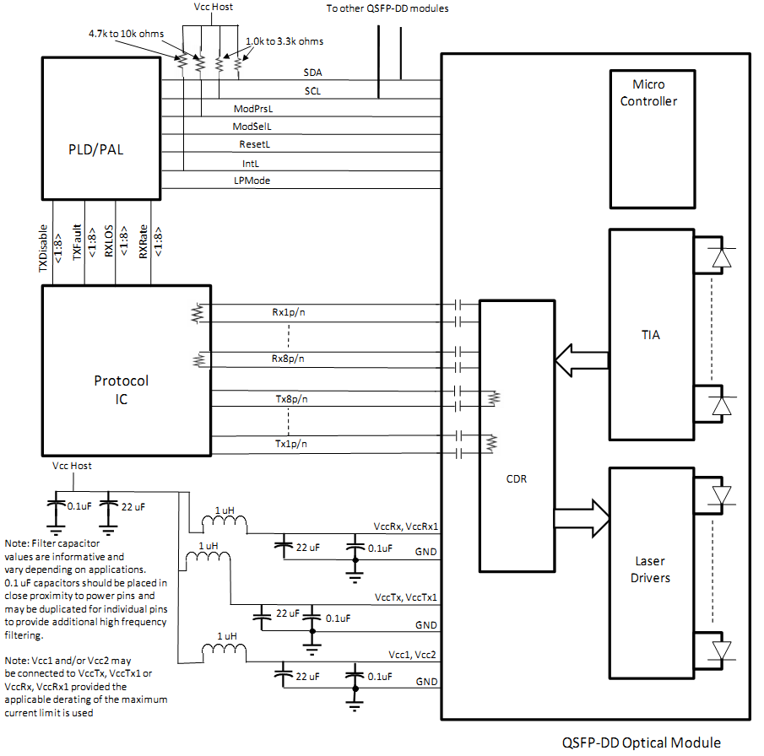
Figure 1, Recommended Interface Circuit

Pin arrangement

OSFP end
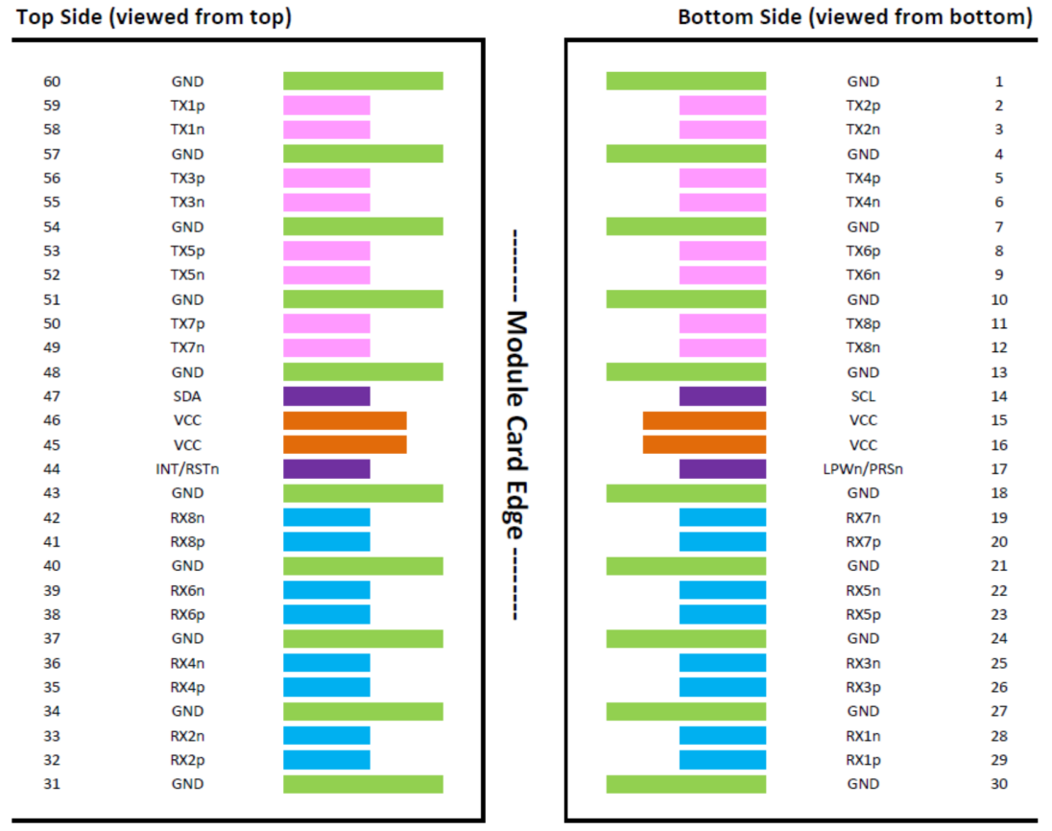
Figure 2, Pin View for OSFP

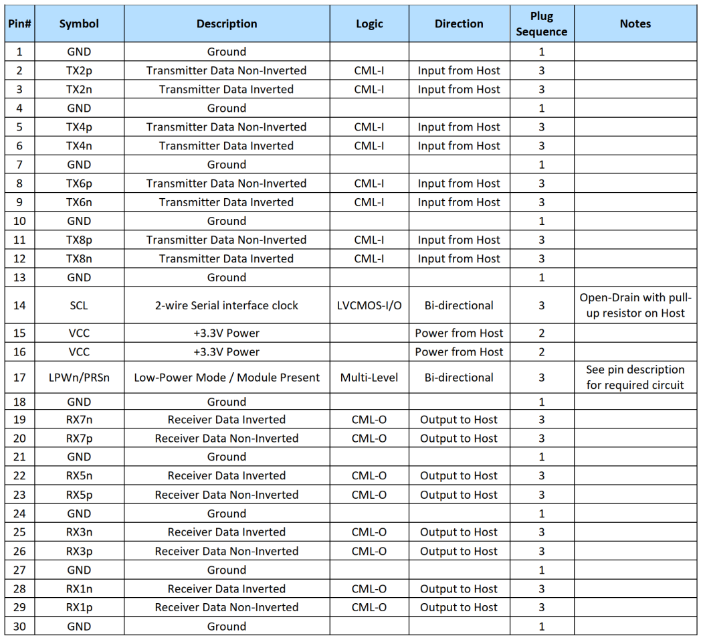
Table 5-Pin Function Definitions for OSFP

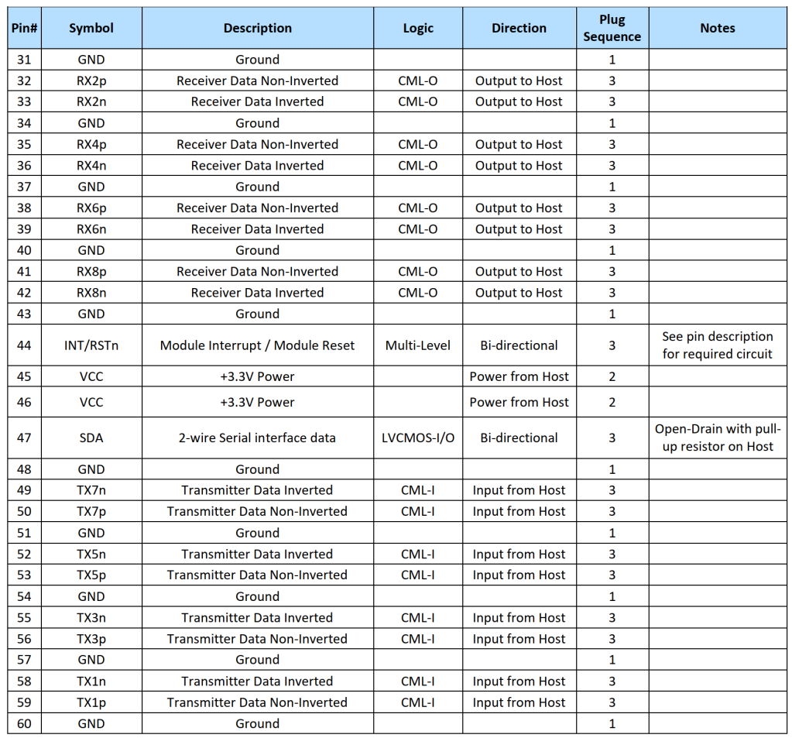

QSFP56 end
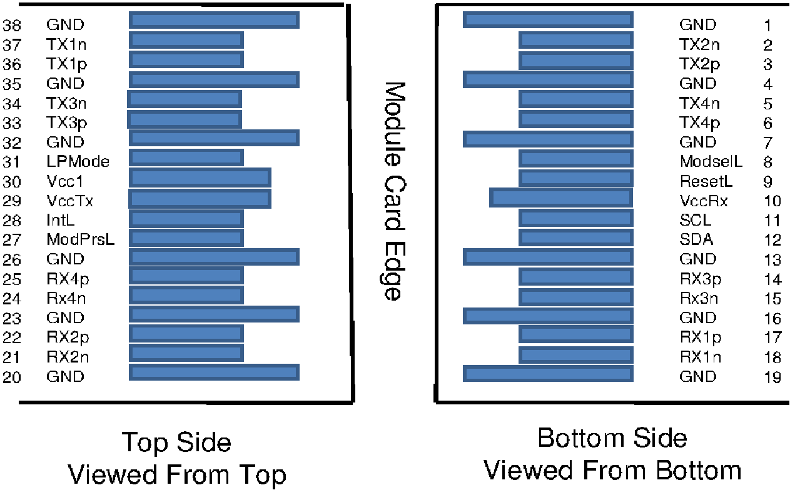
Figure 3, Pin View for QSFP56

Table 6-Pin Function Definitions for QSFP56
Pin | Symbol | Name/Description | Notes
1 | GND | Ground | 1
2 | Tx2n | Transmitter Inverted Data Input
3 | Tx2p | Transmitter Non-Inverted Data Input
4 | GND | Ground | 1
5 | Tx4n | Transmitter Inverted Data Input
6 | Tx4p | Transmitter Non-Inverted Data Input
7 | GND | Ground | 1
8 | ModSelL | Module Select
9 | ResetL | Module Reset
10 | Vcc Rx | +3.3V Power Supply Receiver
11 | SCL | 2-wire serial interface clock
12 | SDA | 2-wire serial interface data
13 | GND | Ground | 1
14 | Rx3p | Receiver Non-Inverted Data Output
15 | Rx3n | Receiver Inverted Data Output
16 | GND | Ground | 1
17 | Rx1p | Receiver Non-Inverted Data Output
18 | Rx1n | Receiver Inverted Data Output
19 | GND | Ground | 1
20 | GND | Ground | 1
21 | Rx2n | Receiver Inverted Data Output
22 | Rx2p | Receiver Non-Inverted Data Output
23 | GND | Ground | 1
24 | Rx4n | Receiver Inverted Data Output
25 | Rx4p | Receiver Non-Inverted Data Output
26 | GND | Ground | 1
27 | ModPrsL | Module Present
28 | IntL | Interrupt
29 | Vcc Tx | +3.3V Power supply transmitter
30 | Vcc1 | +3.3V Power supply
31 | LPMode | Low Power Mode
32 | GND | Ground | 1
33 | Tx3p | Transmitter Non-Inverted Data Input
34 | Tx3n | Transmitter Inverted Data Input
35 | GND | Ground | 1
36 | Tx1p | Transmitter Non-Inverted Data Input
37 | Tx1n | Transmitter Inverted Data Input
38 | GND | Ground | 1
Note: 1. Circuit ground is internally isolated from chassis ground.

Monitoring Specification
400G OSFP end Compatible with CMIS rev 5.2;
200G QSFP56 end Compatible with SFF-8636.

Mechanical

OSFP end

Unit mm

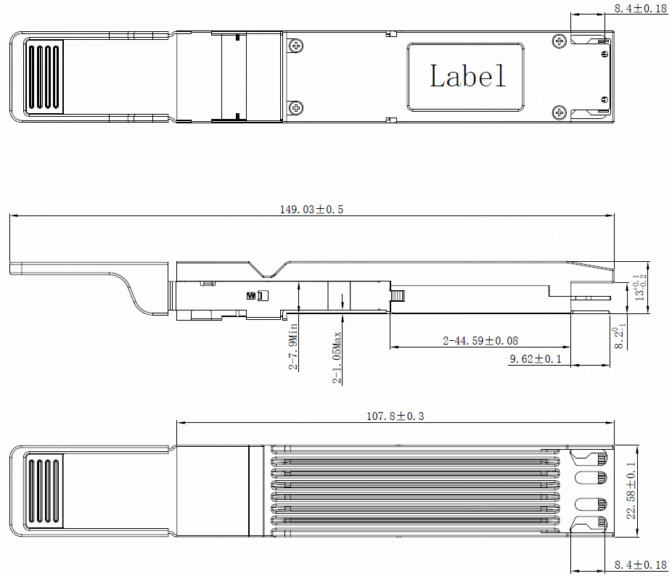
Figure 4,Mechanical Diagram for OSFP

QSFP56 end
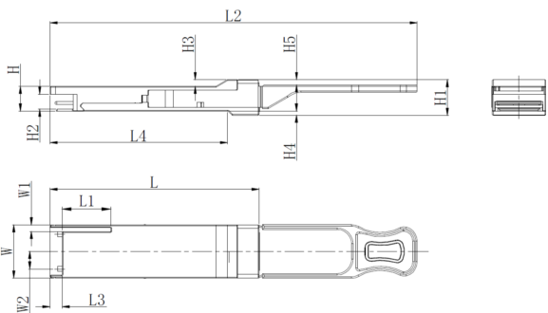

Unit mm
 | L | L1 | L2 | L3 | L4 | W | W1 | W2 | H | H1 | H2 | H3 | H4 | H5 | H6
Max | 72.2 | - | 128 | 4.35 | 61.4 | 18.45 | - | 6.2 | 8.6 | 12.4 | 5.35 | 2.5 | 1.6 | 2.0 | -
Type | 72.0 | - | - | 4.20 | 61.2 | 18.35 | - | - | 8.5 | 12.2 | 5.2 | 2.3 | 1.5 | 1.8 | 6.55
Min | 68.8 | 16.5 | 124 | 4.05 | 61.0 | 18.25 | 2.2 | 5.8 | 8.4 | 12.0 | 5.05 | 2.1 | 1.3 | 1.6 | -
Figure 5, Mechanical Diagram for QSFP56

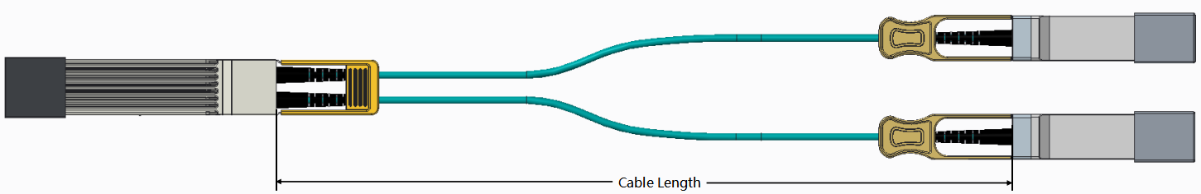

Figure 6, Mechanical Diagram of Cable
Table 7- Cable Length
Parameter | Value | Units
Diameter | 3±0.2 | mm
Minimum bend radius | 30 | mm
Length tolerance | 1 m ≤length ≤ 4.5 m: +15 / -0 | cm
Length tolerance | 5 m ≤length ≤ 14.5 m: +30 / -0 | cm
Length tolerance | Length ≥ 15.0 m +2% / -0 | m
Cable color | Aqua

Table 8- Breakout Cable Nominal Length
Total Length  X (Unit: m) | Breakout Point Measured from OSFP  LQ (Unit: m) | Breakout Point Measured from QSFP56  LS(Unit: m)
1 | 0.3 | 0.7
2 | 0.6 | 1.4
3 | 1 | 2
5 | 2 | 3
7 | 4 | 3
10 | 7 | 3
15 | 12 | 3
20 | 17 | 3
25 | 22 | 3
30 | 27 | 3

Table 9: Connectivity Schematic
400Gb/s Side | 200Gb/s Side
 | Port 1
TX1 | RX1
RX1 | TX1
TX2 | RX2
RX2 | TX2
TX3 | RX3
RX3 | TX3
TX4 | RX4
RX4 | TX4
 | Port 2
TX5 | RX1
RX5 | TX1
TX6 | RX2
RX6 | TX2
TX7 | RX3
RX7 | TX3
TX8 | RX4
RX8 | TX4

Warnings
Handling Precautions: This device is susceptible to damage as a result of electrostatic discharge (ESD).
A static free environment is highly recommended. Follow guidelines according to proper ESD procedures.
Laser Safety: Radiation emitted by laser devices can be dangerous to human eyes. Avoid eye exposure to direct or indirect radiation.

